Apache Kafka
What is Apache Kafka?
- Is an open-source distributed, event streaming platform.
- Used to publish, store, and process streams of records in real-time
Kafka Components
- Topic:
  - is a named category of records
  - logical category used to organize and store related messages
  - producer send messages to the topic and consumers read messages from topic
  - Kafka topics is divided into partitions which allows scalability and parallel processing on messages
  - Topic is a collection of partitions
- Partition
  - Partition is the smaller, ordered log inside a Kafka topic
  - Kafka topic is divided into one or more partitions so Kafka cam store and process large amounts of data efficiently
  - The main reason of using partitions is parallelism and scalability
  - Multiple consumers can process different partitions in parallel
  - Note: ordering is guaranteed within a partition, not across the entire topic
- Offset
  - An offset is a unique number that identifies the position of a message inside a Kafka partition
  - Think of it like the index/position of a message
  - The consumer uses the offset to remember where it is in the partition
  - Offset allowing consumers to keep track of what they have read
- Message
  - Is a piece of data/event that a producer sends to Kafka topic
  - Think of it as a one of record of information
  - Messages are stored in partitions
  - Each message gets an offset within its partition
  - Message can contain different types of data
- Producers
  - Is an application or system that send messages/events to Kafka topic
  - Producer doesn’t send directly to the consumer, it sends messages/events to the Kafka topic, and consumers read messages/events from the Kafka topic
- Consumers
  - Is an application or system that reads messages/events from the Kafka topics
  - Consumers knows its position using offset
  - Consumer doesn’t normally remove the messages from Kafka after reading it, that means another consumer can read the same message independently
Kafka Commands
bin/kafka-topics.sh --help | Display available options and usage for the command
bin/kafka-topics.sh --bootstrap-server localhost:9092 --list | Is a command used for listing Kafka topics

What a Kafka Producers?
- Write messages to Kafka topics, sometimes called publisher
- Messages send via producers are stored on Kafka for later use
- Can have many producers
- Producers can write to one or multiple topics as required
Types of Producers
- Command-line
  - kafka-console.producer.sh
- in addition to the command-line tool, API libraries are available for Python, Java, and many other languages
- Kafka connect: is designed to interact with existing systems such as relational databases, and automatically transfer data between them
kafka-console.producer.sh
- It is normally found in the Kafka bin directory, along with other Kafka tools
  - bin/kafka-console-producer.sh
- several command-line options, some required, others not
- required options
  - --bootstrap-server specifies which server to use
    - --bootstrap-server localhost:9092
  - -- topic which requires the topic to write to
    - --topic phishing-sites
- Use Ctrl-C to exit
- Can also use | symbol to pass messages
- Example
  - bin/kafka-console-producer.sh –bootstrap-server localhost:9092 --topic testing
  - once run, can enter our messages like down and use Ctrl+C to exit
    - > this is the first message
    - > This is the second message
    - > this is the third message
    - ctrl+c to exit
- Non-interactive example
  - echo "this is the first message" | bin/kafka-console-producer.sh --bootstrap-server localhost:9092 --topic testing`
Kafka Consumers
- reads message from Kafka topics, sometimes called subscribers
- there can many consumers communicate with a Kafka system at a time
- consumers can read from one or multiple topics
Types of Consumers
- many different kinds of consumers
- command-like
  - kafka-console-consumer.sh
- there are also components within Kafka connect that allow users to read data from Kafka topics
kafka-console-consumer.sh
- it is normally found in the Kafka bin directory, along with other Kafka tools
  - bin/kafka-console-consumer.sh
- several options, some required
  - --topic
  - --bootstrap-server
  - Use ctrl+c to exit
- Optional arguments
  - --from-beginning
    - Tells Kafka system to send all message in topic, even ones that may have been already read
  - --max-messages <number>
    - Used to read up to a maximum number of messages before exiting

Interactive example
- bin/kafka-console-consumer.sh --bootstrap-server localhost:9092
--topic testing --from-beginning
  - > this is the first message
  - > this is the second message
  - > this is the third message
  - Ctrl + c
Non-interactive example
- bin/kafka-console-consumer.sh --bootstrap-server localhost:9092
--topic testing --from-beginning --max-messages 2
  - this is the first message
  - this is the second message
Kafka Architecture
- Kafka server
  - A cluster of one or more computers
  - Stores data
  - Manages communications
  - Can also integrate with other systems (databases, logs, …)
- Kafka client
  - Read via Kafka consumer
  - Write via Kafka producer
  - Process data as required
Kafka server
- The primary task of a Kafka server is acting as a Kafka broker
- Broker handles communication between consumers and producers
- The server also handles data storage
- Data written by producers is stored and organized via topics
- Topics are partitioned, meaning that they are stored in separate pieces
- Messages are retrieved in same order as written
Partitions & replication
- Kafka is fault-tolerant, if one system goes offline, other can provide the requested data
- For each Kafka cluster, there is a replication factor
- Max number of failure -1 = replication factor
- Max replication factor == number of servers
- The fault-tolerance is handled by replication topic partitions within the cluster
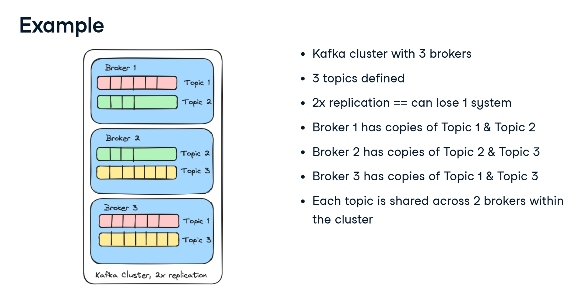
What is Zookeeper?
- Zookeeper is a framework to manage information and provide services necessary for running distributed systems
- Zookeeper primarily used by developer to create distributed applications
  - Users interact with Zookeeper
- Example applications
  - Kafka
  - Hadoop
  - Neo4j
What does zookeeper do?
- Zookeeper provides services necessary to run distributed applications
  - Handling configuration information
  - Naming systems to prevent conflicts
  - Provides the ability to synchronize across systems, such as determining what systems are available, when they should start, …
- Zookeeper designed as a framework to prevent individual distributed applications from implementing custom versions of services
Zookeeper and Kafka
- Kafka uses Zookeeper for cluster management
  - Newer versions of Kafka can use KRaft
- Kafka uses two primary configuration files for server /cluster
  - config/zookeeper.properties
  - config/server.properties
- the primary Kafka server configuration file is the config/server.properties file
  - broker details
  - network configuration
  - event storage location
  - basic topic configurations, including replication
starting a Kafka cluster
- Kafka clusters are started in two pieces
  - bin/zookeeper-server-start.sh config/zookeeper.properties
    - this start up the basic zookeeper server and configuration details found in the zookeeper.properties
  - bin/kafka-server-start.sh config/server.properties
    - which will start the actual Kafka services as defined in the server.properties file
stopping a Kafka cluster
- top stop the Kafka cluster, we do the reverse using
  - bin/kafka-server-stop.sh
  - bin/zookeeper-server-stop.sh
- note the reverse order of shutdown
Kafka Topics
- topics are logical grouping of events
- topic is similar to table in relational database, where each event has a similar structure and meaning
- a topic is sometimes referred to as an event log, and messages written to the log are immutable
- messages in a topic can be read or written, but not modified

Creating Topics
- multiple ways to create topics
- we’ll use the bin/kafka-topics.sh script
bin/kafka-topics.sh
--bootstrap-server <server>
--topic <topic_name>
--create
- example
  - bin/kafka-topics.sh –bootstrap-server localhost:9092 --topic orders –create
Other Variations
- optional arguments for bin/kafka-topics.sh --create
  - --replication-factor <x>
    - Define the replication factor of the topic
  - --partitions <x>
    - Specify the number of partitions manually
  - --describe
    - Get details about the topic configuration
  - Example
    - bin/kafka-topics.sh --bootstrap-server localhost:9092 --topic orders --create --replication-factor 3
--partitions 3
  - Example
    - bin/kafka-topics.sh --bootstrap-server localhost:9092 --topic orders --describe
Removing Topics
- used to remove the topic from the Kafka server/cluster, and it’s important note that also removes all messages in the topic
- example
  - bin/kafka-topics.sh --bootstrap localhost:9092
--topic orders --delete

Kafka Troubleshooting
- The finding and fixing problems that happens when using Apache Kafka

Kafka Broker is not running
- You run the following example
bin/kafka-console-producer.sh \
--bootstrap-server localhost:9092 \
--topic test
- You get:
  - Connection to node -1 could not be established
  - Problem: Kafka broker may not be running
  - Check
    - jps
  - then check port
    - ss -lntp | grep 9092
Wrong Bootstrap Server
- you run
  - bin/kafka-console-consumer.sh --bootstrap-server localhost:9093 --topic test
- problem wrong port
- fix
  - bin/kafka-console-consumer.sh –bootstrap-server localhost:9092 --topic test
Topic Doesn’t Exist
- you run
  - bin/kafka-console-producer.sh --bootstrap-server localhost:9092 --topic sales
- but sales doesn’t exist
- check
  - bin/kafka-console-producer.sh --bootstrap-server localhost:9092 --list
  - if sales doesn’t exist there, create it
bin/kafka-topics.sh –bootstrap-server localhost:9092 --create --topic sales --partitions 3 --replication-factor
Consumer Doesn’t Show Old Messages
- you produced the following
  - Hello
  - Kafka
  - Message 3
- Then you start
  - bin/kafka-console-consumer.sh --bootstrap-server localhost:9092 --topic test
- you don’t see the old messages
  - problem: the consumer isn’t necessary reading from the beginning
  - fix it as following
    - bin/kafka-console-consumer.sh --bootstrap-server localhost:9092 --topic test --from-beginning
  - now you can read the existing messages from the beginning
Port 9092 is already being used
- Kafka tries to start, but you get something like:
  - Address already in use
- Check
  - sudo lsof -i :9092
- you discover another process is using port 9092
- problem: port conflict
- troubleshooting: identify the process and either stop it or configure Kafka to use another port
Kafka Start Then Stop
- you start Kafka, but it immediately shuts down
- you check the Kafka logs
  - tail -f logs/server.log
- you might find
  - Permission denied
- Problem: Kafka does not have permission to access log/data directory
- Troubleshooting: check ownership and permissions of the relevant directories

